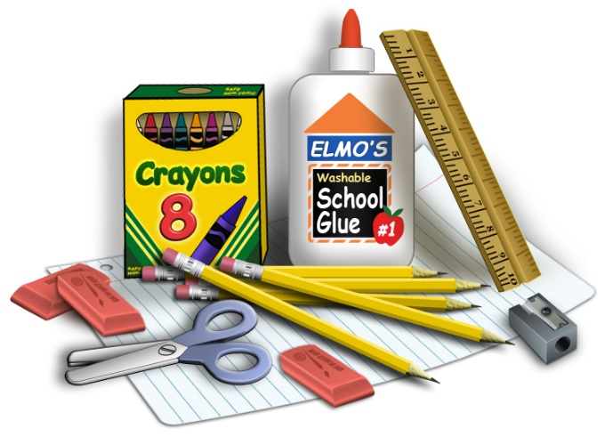
Kindergarten Wish List

Dear Kinder families,
Here is a list of items we use throughout the 24-25 school year. If you are able to contribute to your child’s classroom, we would appreciate it. Please see your child’s teacher if you have questions. Thank you!

· Wired over ear head phones (not ear buds)—for your child to use
· Reusable water bottle—for your child to use
· Snacks—individually wrapped snacks are preferred
· Kleenex tissues
· Paper towels
· Baby wipes
· Clorox wipes
· Play-doh brand playdough
· Sandwich bags—zipper closure
· Gallon sized ziplock bags—with zipper closure
· Elmer’s Glue sticks

